**INTI International College Penang School of Engineering and Technology**

**3+0 Bachelor of Science (Hons) in Computer Science, in collaboration with Coventry University, UK**

**3+0 Bachelor of Science (Hons) in Computing, in collaboration with Coventry University, UK**

**Coursework cover sheet**

**Section A - To be completed by the student**

|  |  |
| --- | --- |
| Full Name: CHU ZHI XUAN | |
| CU Student ID Number:12673128 | |
| Semester: JAN 2022 | |
| Session:  **April 2022** | |
| Lecturer:  **Nadhrah Abdul Hadi (nadhrah.abdulhadi@newinti.edu.my)** | |
| Module Code and Title:  **4067CEM Software Design** | |
| Assignment No. / Title:  **Continuous Assessment** | % of Module Mark:  **50** |
| Hand out Date:  **22nd April 2022** | Due Date:  **Task 1: 13 May 2022, by 11.59pm**  **Task 2: 1 July 2022, by 11.59pm**  **Task 3: 17 June 2022, by 11.59pm.**  **Task 4: 17 June 2022, by 11.59pm.**  **Task 5: 17 June 2022, by 11.59pm.** |
| Penalties: No late work will be accepted. If you are unable to submit coursework on time due to extenuating circumstances, you may be eligible for an extension. Please consult the lecturer. | |
| Declaration: I/we the undersigned confirm that I/we have read and agree to abide by the University regulations on plagiarism and cheating and Faculty coursework policies and procedures. I/we confirm that this piece of work is my/our own. I/we consent to appropriate storage of our work for plagiarism checking.  Signature(s): ________________________ | |

**Section B - To be completed by the module leader**

|  |  |  |
| --- | --- | --- |
| Intended learning outcomes assessed by this work:  1. Understand and apply appropriate concepts, tools and techniques to each stage of the software development  2. Understand and apply design patterns to software components in developing new software  3. Demonstrate an understanding of project planning and working to agreed deadlines, along with professional, interpersonal skills and effective communication required for software production  5. Demonstrate an awareness of, and ability to apply, social, professional, legal and ethical standards as documented in relevant laws and professional codes of conduct such as that of the Malaysian National Computer Confederation. | | |
| Marking scheme | Max | Mark |
| 1. User Story Mapping 2. Setting up a GitHub Repository 3. Creating a Class diagram and design pattern selection 4. Creating a Prototype User Interface and Usability Testing 5. Discuss the ethical issue related to the software | 20  10  30  20  20 |  |
| Total | 100 |  |

# Important features in the proposed system

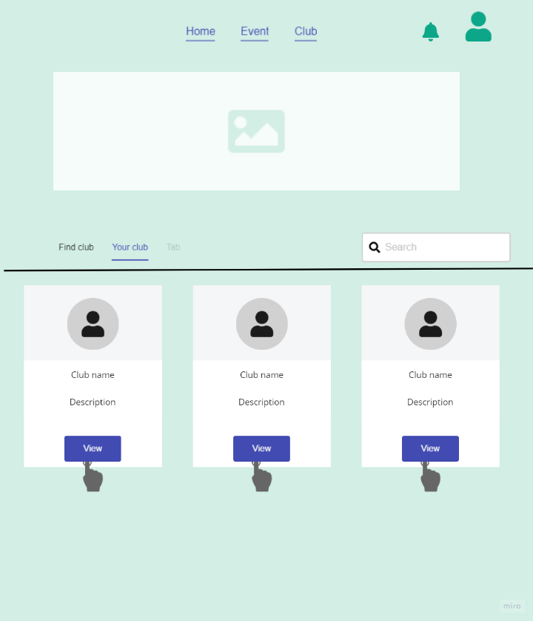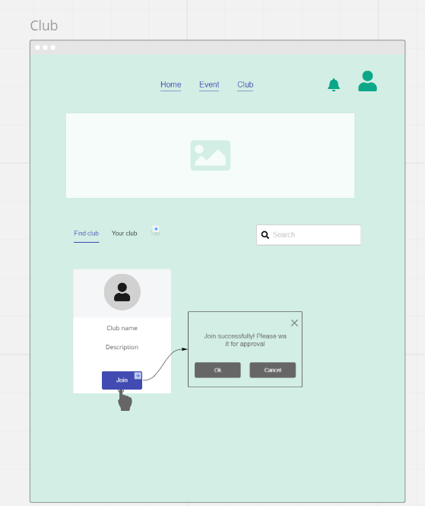The club

This features allows the student view the existing club in this page and student can know each club name and the description of the club ,therefore the freshman can get more familiar with every club in terms what they are doing for. Moreover, there is a search features for student can quick search by typing the club name to save the time on searching. After that, student can press the button ‘Join’ if they want to and will pop out the message for waiting approval of the club admin. Then the club admin approve the request and the student will get the notification. When clicked ‘Your Club’, the page will show the club that student have joined and able to view the club information and event when click the ‘view’ button.

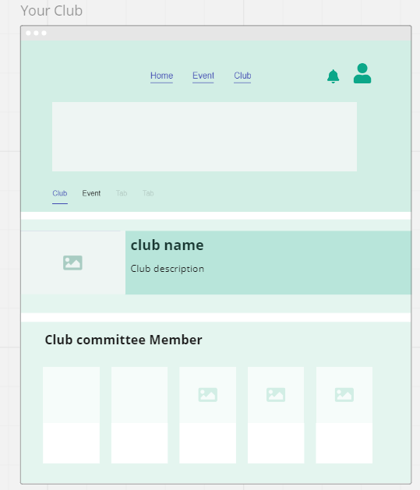

On this page, the student can know the club committee member of each club and also the event they have organised.

The reason why these features are needed because we concern about the freshman student of the college don’t know what exactly the clubs have in the college, so the features can delivery the information of clubs to the student. Beside that, we can gather all the clubs in one website to reduce the wasting the resource and time in other social platform since the students have access to this website.

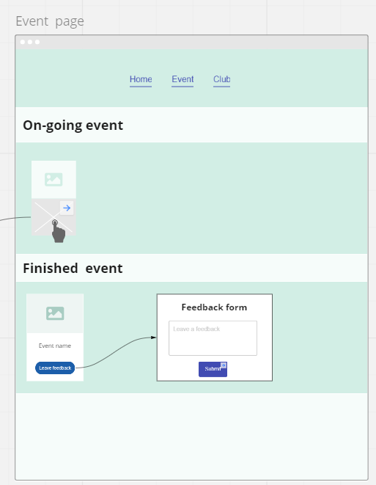Event page

This page contains the on-going event and finished event. The on-going event have image components and the description and can be clicked to proceed to other page. In the finished event container will display that the student had joined the event and provide feedback button to submit the feedback form to the organiser.

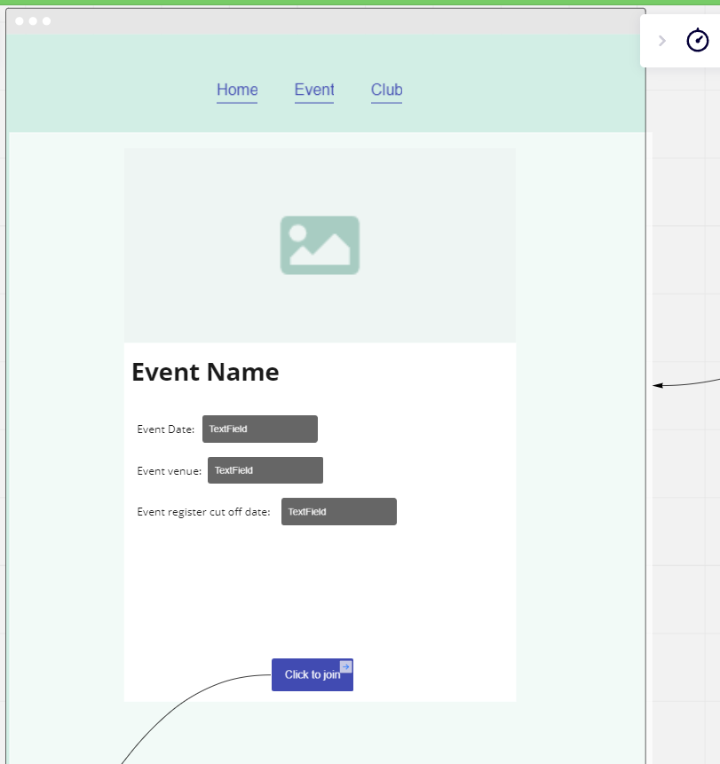

Once the event card being clicked, it will procced to this page and bring the event details information to the student. The student may click the button to join if they are interested.

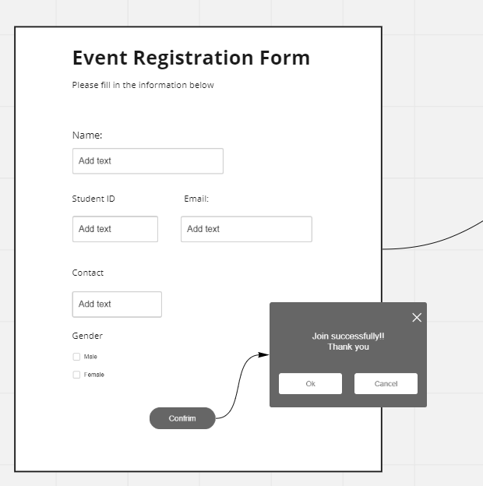 Then it will pop out the registration form to fill up the student information and click confirm button and student are joined to the event. And then press ok will return to club main page.

The main objective of this features to provide better solution for sign up registration to replace to the google forms. The google forms have limitation for customization and the concern of data security. In addition, the system will automated generate the report who are going to joined the event to the club admin.

**Usability Questions**

1. How do you do for first login for this website ?
2. How would you do to procced to club / event page ?
3. How would you do to join the club?
4. How would you think the way to join the club? If there any improvement?
5. How would you view the club have joined?
6. How would you do to see the notification ?
7. How would you do to join the event ?
8. How you do change the password if forgot it?

Link-<https://miro.com/app/board/uXjVO0eLz8A=/?share_link_id=872593979681>